Carry on
The Smiths of Lower Crispin have reusable bags for their food shopping and are very fastidious about how they are packed. They have just returned from a supermarket and are currently enjoying a cup of tea and a biscuit before putting the goods away. Can you say what type of goods is in each of six bags and how many items each bag contains?

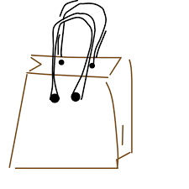
1. ……………………………. 2. ………………………… 3. …………………………………
…………………………….. …………………………. ………………………………….
4. …………………………… 5. …………………………. 6. ……………………………….
…………………………… ………………………….. …………………………………

Clues:
1. The bag containing the tins and bottles is directly behind the bag containing nine items. Bag number 5 contains the milk and other dairy products and contains one more of those items than the number in bag 1.
2. The bread, cakes and biscuits are in the bag immediately to the right of the bag containing twelve items and contains one more item than there are in the bag of fruit and veg.
3. The Smiths have bought eight frozen food items. The bag with seven items in it is in the front row.
4. The bag containing the fresh meat is immediately to the left of the bag that contains two more items than there are in the bag of fresh meat.

Items: bread, cakes and biscuits - fresh meat - frozen food – fruit and veg – milk and dairy – tins and bottles
Numbers: 7, 8, 9, 10, 11, 12
Starting tip: Work out what type of goods the Smiths have bought seven items

