How I Met Your Mother
is an American sitcom created by Craig Thomas and Carter Bays for CBS. The series, which ran from 2005 to 2014, follows the main character, Ted, and his group of friends in New York City's Manhattan. The series was loosely inspired by Thomas and Bays' friendship when they both lived in New York City.
Ted is verbally retelling the story of how he met the mother of his children, to his son Luke and his daughter Penny as they sit on the couch in the year 2030. The story goes into a flashback
While the traditional love story structure begins when the romantic leads first encounter each other, How I Met Your Mother does not introduce Ted’s wife until the eighth-season finale and only announces her name during the series finale. The show instead focuses on Ted’s prior relationships and his dissatisfaction with those women, thus setting the stage for his eventual happiness with his future wife. Finally in present 2030, six years after his wife’s death, ………… well If you want to know what happens, you have to watch it all

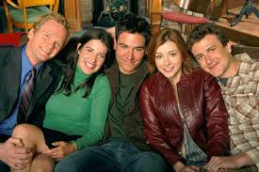

1. Match the picture with the first name, surname and job of the character:

A. 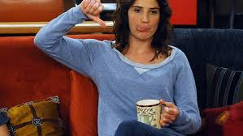 B. 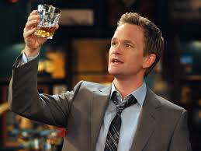
C. D.
E.

FIRST NAME SURNAME JOB
Lili Stinson architect
Robin Mosby law student
Marshall Scherbatsky unknown
Ted Aldrin news reporter
Barney Eriksen kindergarden teacher
2. Describe each character in five words
Ted …………………………………………………………………………………………………………………………………………
Lili …………………………………………………………………………………………………………………………………………..
Robin ………………………………………………………………………………………………………………………………………
Marshall …………………………………………………………………………………………………………………………………
Barney ……………………………………………………………………………………………………………………………………

3. True or False?
- Ted’s kids are excited when he starts telling the story of how he met their mother.
- Ted’s best friend is Marshall.
- Lili is Canadian.
- Barney has a thing for Latin girls.
- Ted has already got a perfect wedding day planed.
- Marshall is really good in opening a champagne bottle.
- Ted didn’t kiss Robin because he didn’t have a blue horn.
- Robin wanted Ted to kiss her.
- Ted went to see Robin at 3 o’clock in the morning.
- Marshall loves olives.
- Robin is the mother of Ted’s kids.

4. Answer the question
- What year does Ted go back to start telling the story?
- Who is according to Lili the dumbest person alive?
- What are the two most popular Barney’s phrases?
- What did happen to Marshall when he cooked dinner the last time?
- Which words you should never say on your first date according to Ted?
- What are the characteristics of a perfect woman according Ted? (4)
- What are the two most important questions in man’s life?
- What did Marshall and Lili ordered on their first date?
- How did Ted ruin “the first date” with Robin?
- What game does Barney like to play?
- What is the “Olive theory” about?
5. Practice your vocabulary – translate:
chicken out
spank
screw something up
propose
take the lead
under a condition
get somebody drunk
eccentric
to be turned on
fiancée
It sucks.
virgin
cuddly
desperate
phoney
cute
childish
commit to somebody

