Čtěte a spojujte. Očíslujte obrázky. Napište jména zvířat.

1  I live in Africa. I have four long legs and a very long neck.  __ __ __ __ __ __ __ | 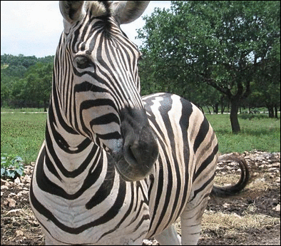  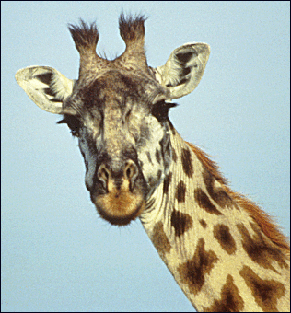  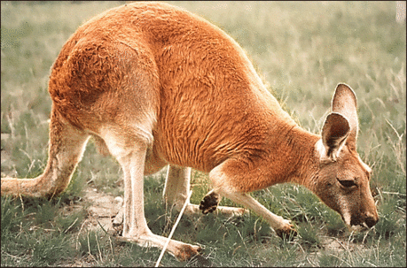  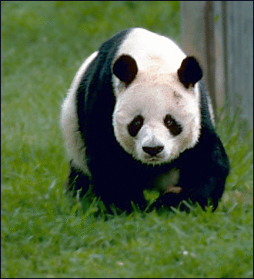  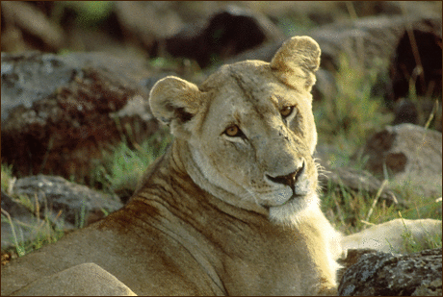  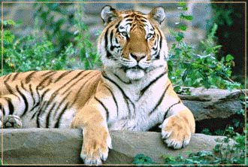 | 4  I live in Africa and Asia. I am a big cat. I have yellow and brown fur.  __ __ __ __
2  I am a dangerous animal. I live in Asia. I am a big cat. My fur is orange and white with black lines.  __ __ __ __ __ |  | 5  I am an African animal. I look like a horse. I have black and white stripes on my body.  __ __ __ __ __
3  I live in China. I am a bear. I am black and white. I like to eat bamboo.  __ __ __ __ __ |  | 6  I live in Australia. I have a long tail and four legs – two short and two long. I like to jump.  __ __ __ __ __ __ __ __

Čtěte a doplňte text – vyberte slovíčko z rámečku a napište ho do správného místa v textu.

legs | elephant | teeth | two
neck | nose | Africa | tail

There is an _ _ _ _ _ _ _ _ _ _ in the picture. Elephants are large animals. They live in _ _ _ _ _ _ _ _ _ _ and Asia. They have a big body. They have a very long _ _ _ _ _ _ _ _ _ _ (it is called a trunk). Elephants have large ears and two big _ _ _ _ _ _ _ _ _ _ (called tusks). They have four _ _ _ _ _ _ _ _ _ _ and a _ _ _ _ _ _ _ _ _ _. | 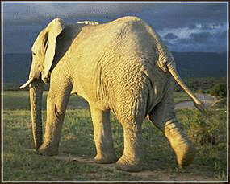  an elephant

Jaké je tvé nejoblíbenější zvíře? Napiš o něm 4 – 6 vět a nakresli ho ☺

_________________________________________
_________________________________________
_________________________________________
_________________________________________
_________________________________________
_________________________________________
_________________________________________
_________________________________________

Použité obrázky:

zebra | Zebra face Clip Art. [cit. 2010-05-06]. Dostupné pod licencí Public Domain na WWW:  <http://www.pdclipart.org/displayimage.php?album=search&cat=0&pos=1>.
žirafa | Giraffe portrait Clip Art. [cit. 2010-05-06]. Dostupné pod licencí Public Domain na WWW:  <http://www.pdclipart.org/displayimage.php?album=search&cat=0&pos=10>.
klokan | Kangaroo Clip Art. [cit. 2010-05-06]. Dostupné pod licencí Public Domain na WWW:  <http://www.pdclipart.org/displayimage.php?album=search&cat=0&pos=1>.
panda | bear Gaint Panda Clip Art. [cit. 2010-05-06]. Dostupné pod licencí Public Domain na WWW: <http://www.pdclipart.org/displayimage.php?album=search&cat=0&pos=1>.
lev | African Lion Clip Art. [cit. 2010-05-06]. Dostupné pod licencí Public Domain na WWW:  <http://www.pdclipart.org/displayimage.php?album=search&cat=0&pos=7>.
tygr | tiger Clip Art. [cit. 2010-05-06]. Dostupné pod licencí Public Domain na WWW: <http://www.pdclipart.org/displayimage.php?album=search&cat=0&pos=8>.
slon | elephant at sunset Clip Art. [cit. 2010-05-06]. Dostupné pod licencí Public Domain na WWW:  <http://www.pdclipart.org/displayimage.php?album=search&cat=0&pos=14>.

