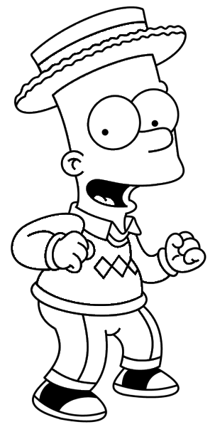
1
4
2
3
7
6
5
10
9
8
11
12
13
Write the parts of the body

- Neck - Eye
- Nose - Finger
- Mouth - Leg
- Ear - Waist
- Toe - Knee
- Foot - Arm
- hand
Colour Bart’s body as indicated:
Eye Nose
Hand Foot
Ear Arm
Waist Neck

