Match words and pictures
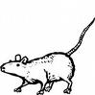
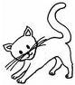
cat
1

1

4

2

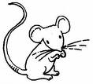
3


cockroach

dog
fish (piranha)
5

8

6

7

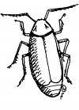

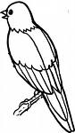
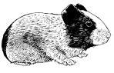
guinea pig

hamster

iguana
mouse

9

11

12

10


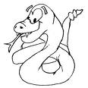
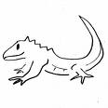
parrot

pig
17

rabbit
13


rat

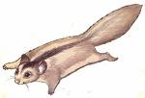
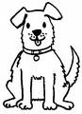
16

14

snake

songbird
15

squirrel

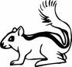
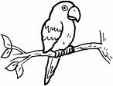
sugar glider
tarantula
turtle
18

Write the words (more than 1 answer possible)

- Most popular pets : …………………………………………………………………………………………
- Meat-eating pets : …………………………………………………………………………………………
- The most colourful pet : …………………………………………………………………………………………
- Your favourite pet : …………………………………………………………………………………………

