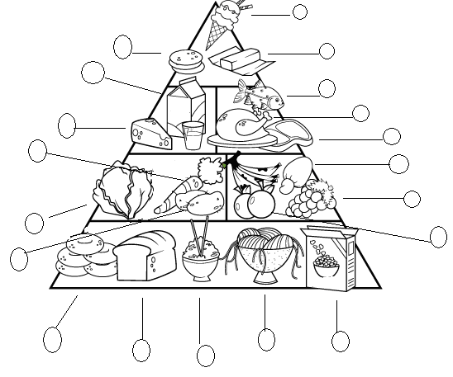
Food Pyramid
1. pasta
2. fish
3. bread
4. ice cream
5. rice
6. lettuce
7. chicken

8. butter
9. cereal
10. oranges
11. carrot
12. steak
13. grapes

14. steak
15. milk
16. bananas
17. potatoes
18. cheese
19. cashew

