How I Met Your Mother
is an American sitcom created by Craig Thomas and Carter Bays for CBS. The series, which ran from 2005 to 2014, follows the main character, Ted, and his group of friends in New York City's Manhattan. The series was loosely inspired by Thomas and Bays' friendship when they both lived in New York City.
Ted is verbally retelling the story of how he met the mother of his children, to his son Luke and his daughter Penny as they sit on the couch in the year 2030. The story goes into a flashback
While the traditional love story structure begins when the romantic leads first encounter each other, How I Met Your Mother does not introduce Ted’s wife until the eighth-season finale and only announces her name during the series finale. The show instead focuses on Ted’s prior relationships and his dissatisfaction with those women, thus setting the stage for his eventual happiness with his future wife. Finally in present 2030, six years after his wife’s death, ………… well If you want to know what happens, you have to watch it all

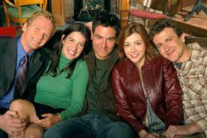

1. Match the picture with the first name, surname and job of the character:

A. 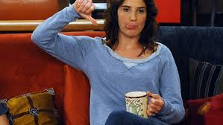 B. 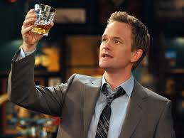
C. D.
E.

FIRST NAME SURNAME JOB
E. Lili Aldrin kindergarden teacher
A. Robin Scherbatsky news reporter
C. Marshall Eriksen law student
D. Ted Mosby architect
B. Barney Stinson unknown
2. Describe each character in five words
Ted – cuddly, desperate, lonely, sweet, clever, ……….
Lili – naive, loving, happy, smiley, silly, creative …………………………
Robin - serious, strong, independent, intelligent, confident, ………………
Marshall – funny, childish, extrovert, gentleman, comfortable, ……………….
Barney – egoistic, mysterious, rich, womanizer, know-it-all, ……………………….

3. True or False?
- Ted’s kids are excited when he starts telling the story of how he met their mother. F
- Ted’s best friend is Marshall. T
- Lili is Canadian. F (Robin is)
- Barney has a thing for Latin girls. F (Lebanese)
- Ted has already got a perfect wedding day planed. T
- Marshall is really good in opening a champagne bottle. F (He is scared of it)
- Ted didn’t kiss Robin because he didn’t have a blue horn. F (He thought he didn’t get the signal)
- Robin wanted Ted to kiss her. T
- Ted went to see Robin at 3 o’clock in the morning. T
- Marshall loves olives. T
- Robin is the mother of Ted’s kids. F (She is their aunt)

4. Answer the question
- What year does Ted go back to start telling the story? - 2005
- Who is according to Lili the dumbest person alive? - Barney
- What are the two most popular Barney’s phrases? - Suit up. Don’t even think about getting married till you’re thirty.
- What did happen to Marshall when he cooked dinner the last time? – He burnt his eyebrows.
- Which words you should never say on your first date according to Ted? - Smurf and penis.
- What are the characteristics of a perfect woman according Ted? (4)
- likes scotch, hates olives, loves dogs, knows the phrases from Ghost Busters movie
- What are the two most important questions in man’s life?
- Will you marry me?
- Will you go on a date with me?
- What did Marshall and Lili ordered on their first date? – Greek salad
- How did Ted ruin “the first date” with Robin? – He said he loves her.
- What game does Barney like to play? – Have you met (Ted)?
- What is the “Olive theory” about? - If one person from a couple loves olives and the other hates them, they are made for each other. The Universe is in balance.
5. Practice your vocabulary – translate:
chicken out – zbaběle se z něčeho vykroutit, vycouvat
spank – naplácat na zadek
screw something up – zpackat něco
propose – požádat o ruku
take the lead – ujmout se vedení
under a condition – pod podmínkou že
get somebody drunk – opít někoho
eccentric - výstřední
to be turned on – být vzrušený
fiancée - snoubenka
It sucks. – To naštve. Stojí to za starou bačkoru.
virgin - panna
cuddly – mazlivý, tulivý
desperate - zoufalý
phoney - divný
cute - roztomilý
childish - dětinský
commit to somebody – zavázat se někomu

